**C128 A/V-Adaptor Rev. 0**

**Testing v0.0**

# Introduction

The test was conducted with a prototype of the A/V-Adaptor Rev. 0. For the electrical/functional tests a C128 was used. A Framemeister XRGB mini was used to connect an (HDMI) monitor.

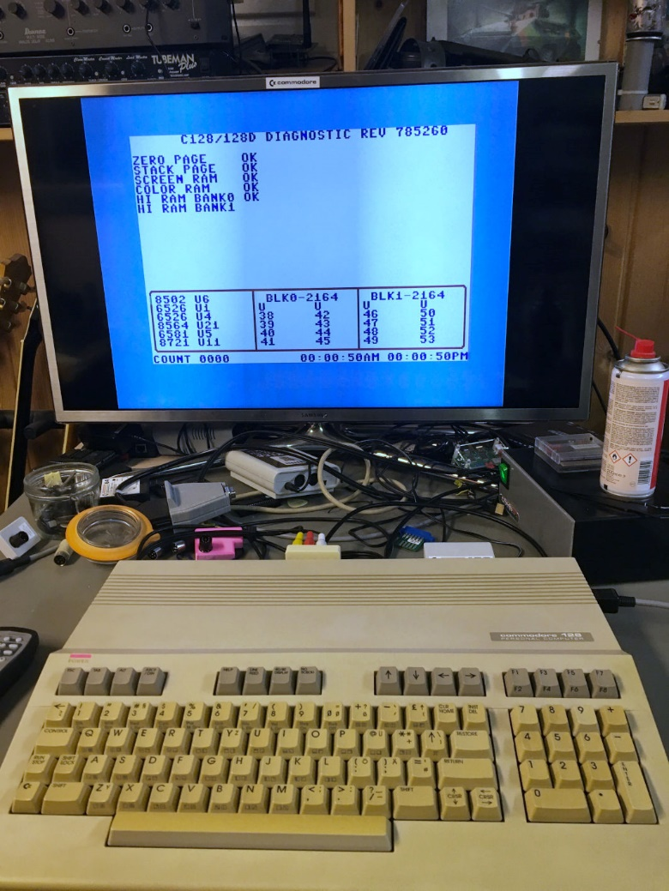

Figure 1: Test Setup

# Tests

## Assembly

The prototype was assembled, all footprints worked out. The DIN plug was assembled the way described in the Module Description. No problems occurred while the assembly.

## Mechanical fitting

The A/V-Adaptor was installed on a C128, which works well with the prototype. It is required to install the DIN plug with a distance to the bottom side of the PCB to get deep enough into the video jack of the C128 to obtain a stabile seating.

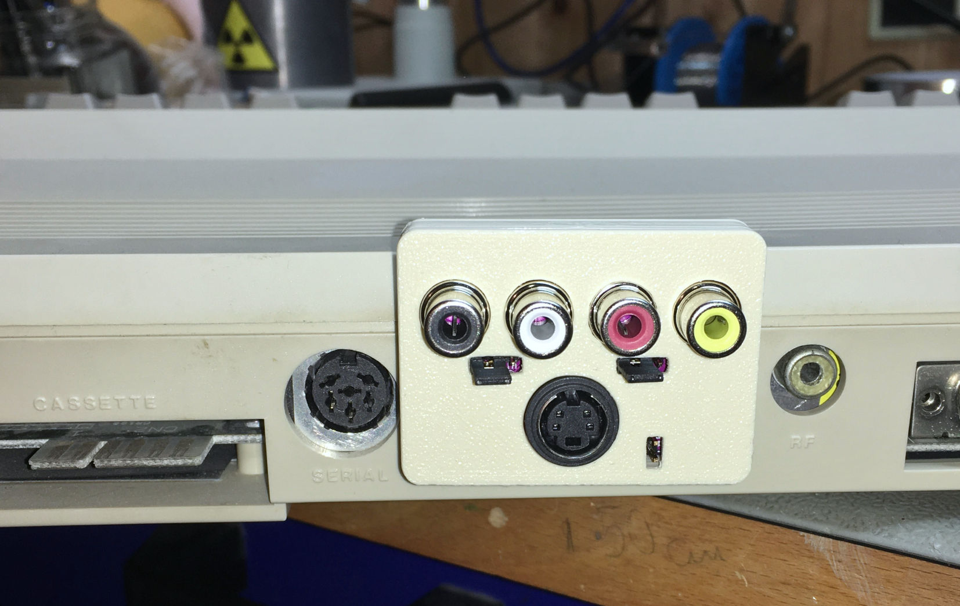

Figure 2: Mechanical testing with a C128.

No ports are blocked.

## Functional testing

The A/V-adaptor was connected to the C128 and the computer was switched on. The jumpers were set to

|  |  |
| --- | --- |
| **Jumper** | **Setting** |
| JP1 (Chroma Hi) | Close (=330R resistor bridged) |
| JP2 (Audio in) | Off (audio in → GND) |
| JP3 (mono/stereo) | Mono (both audio channels connected to J2, Pin 3) |

|  |  |  |
| --- | --- | --- |
| **Test** | **Result** | **Testing** |
| S-Video cable connected | The displayed image was clear and not distorted | Ok |
| Audio cable | Both speakers had a clear audio output (mono) | Ok |
| Composite video | The displayed image was clear and not distorted | Ok |
| Audio input (JP2 → on) | The audio signal connected was passed through the filter. | Ok |
| Stereo mode | TBD | TBD |
| Chroma high (s-video), 330R resistor bridged | The quality of the displayed imaged changed. The colors got stronger and slightly distorted. This was expected. | Ok |

The stereo mode was **not** tested.

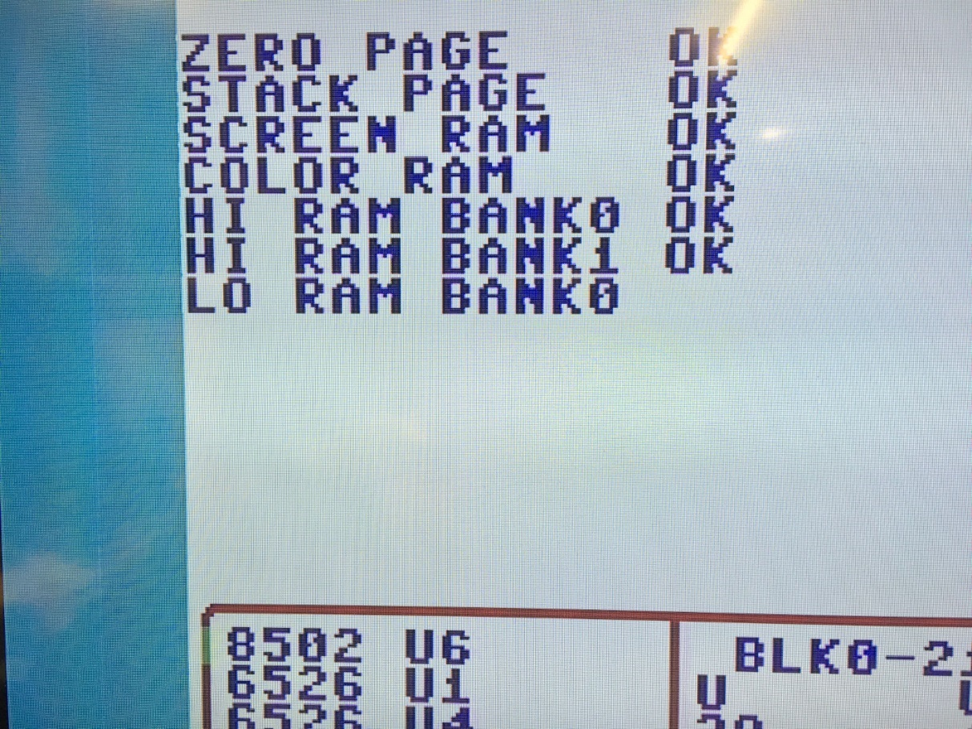

Figure 3: Photography of the S-Video output

## 

Figure 4: Photography of the Composite Video output

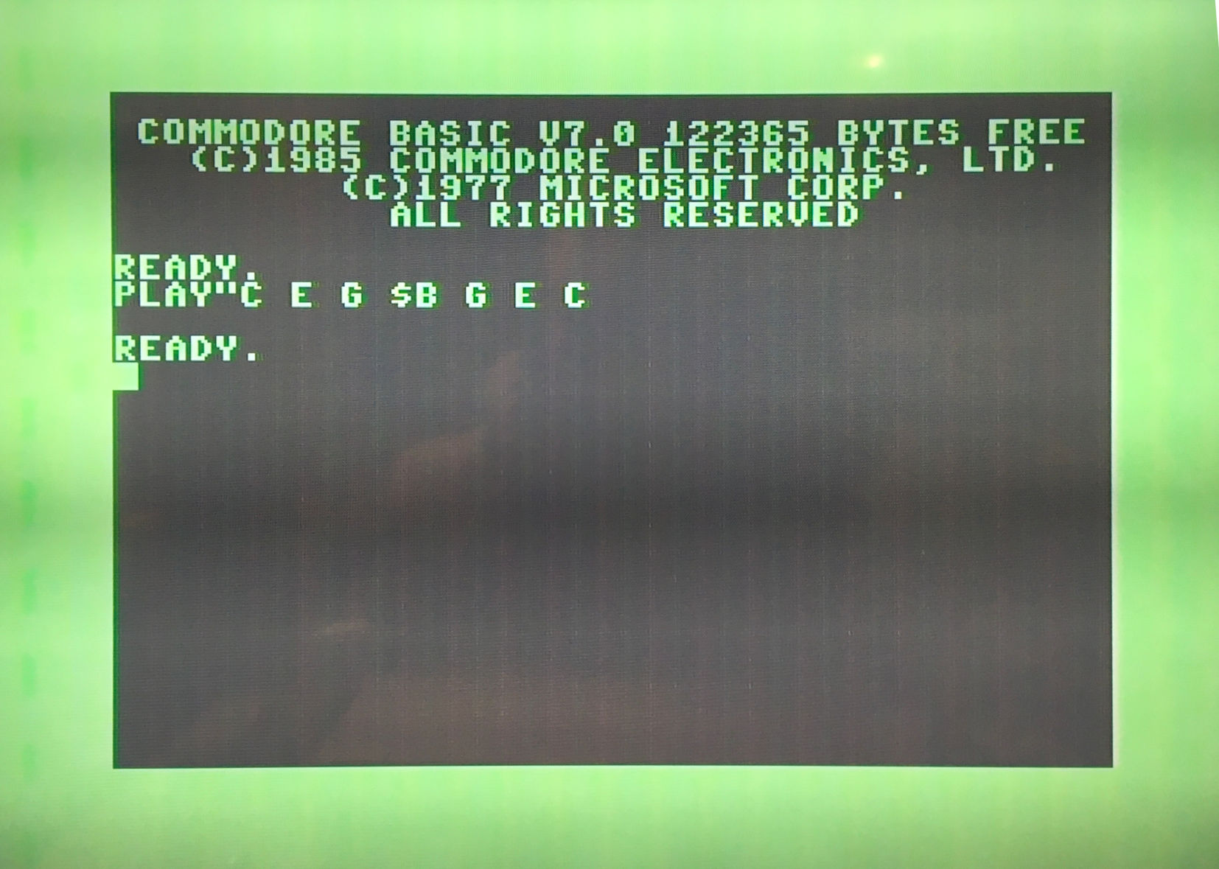

Figure 5: Sound test

The sound test was accomplished by playing some notes from BASIC V7.0. These were audible.

NOTE: Photographing an TFT/LCD-Display never really shows the real image. That is matter due to raster effects (Moiré patterns) and dynamic effects (darker areas/strips).

## 3D-printed cases

After trimming the solder pins of the RCA jacks, all three versions of the board fit into the bottom shell. The respective top shells could be installed and fit well. The decals (labels) fit on the top shell.   
  
The A/V-Adaptors passed a drop test (a drop of 1m on a table top).

# Test Result

The C128 A/V-Adaptor Rev. 0 is fully functional. It seems, that the colors of s-video and composite video are looking more similar, when the jumper “Chroma High” is bridged.